**Signature, Purpose, and Stub**

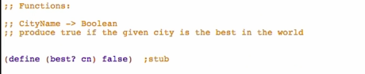

**Examples**

Go back to Design Recipes: <https://courses.edx.org/courses/course-v1:UBCx+HtC1x+2T2017/77860a93562d40bda45e452ea064998b/>

* HtDD
* 
* 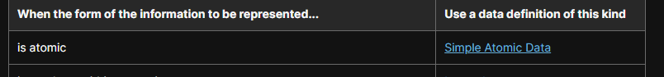

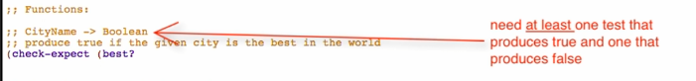



Then make purpose more specific: 

Try running: 

**Inventory – Template & Constants**

Take the template from CityName

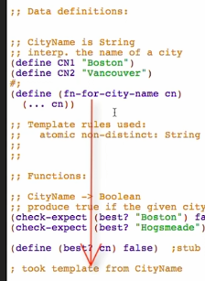

And then rename

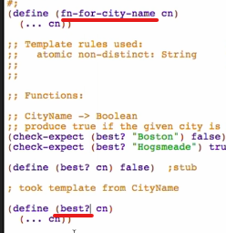

**Code body**

Boolean -> if statement



Condition/question

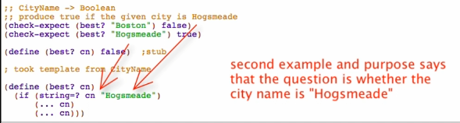

True answer:

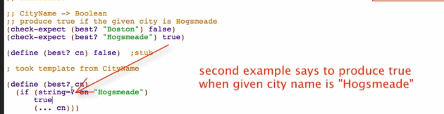

False answer:

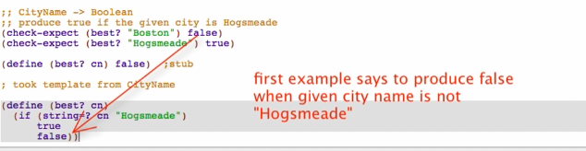

Comment out the stub :  and run

Note:

Templates

* Show you what you CAN use NOT MUST use
* You can delete parts of the template

Refactoring for simplicity:



